MODULE 5.2 : SQL Queries

1. Create Table Name : Student and Exam

➢

Create Student Table:

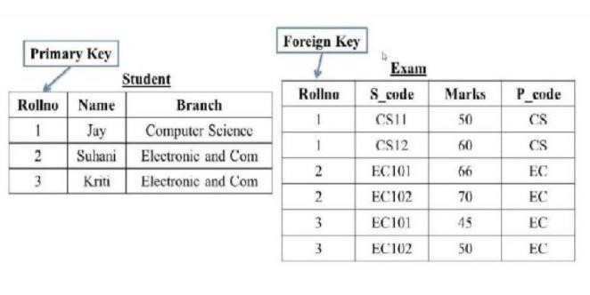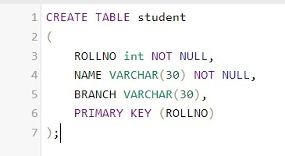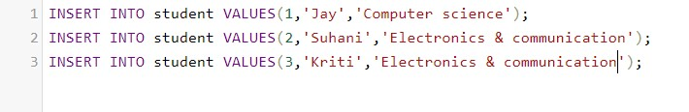

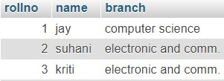

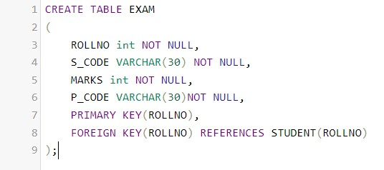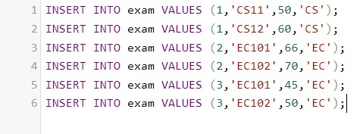

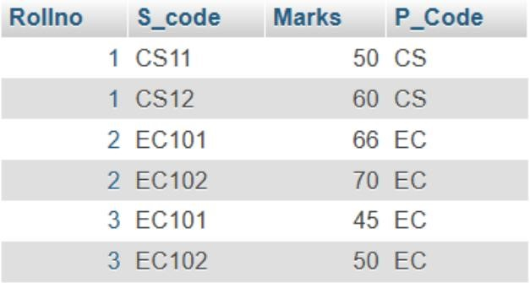

2. **Create table given below: Employee and Incentive Table**

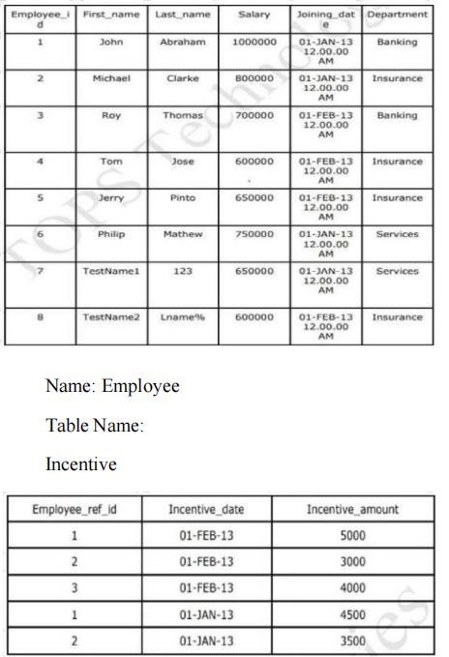

Employee:-

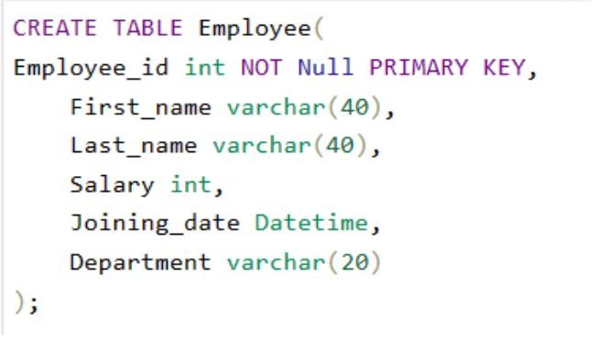

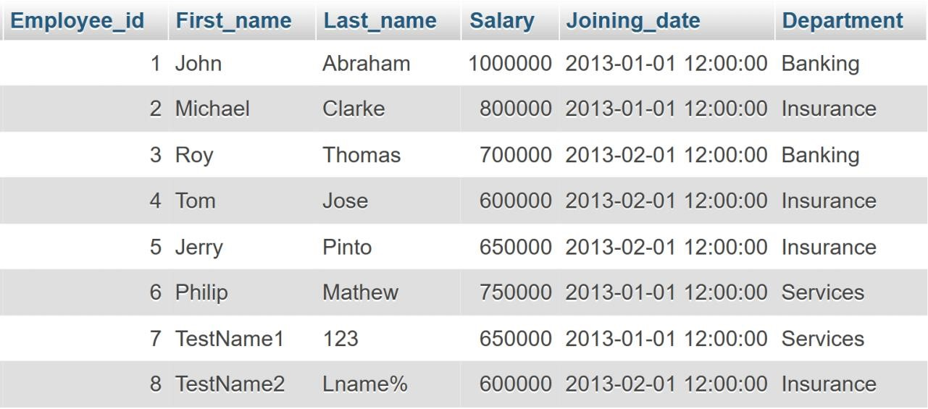

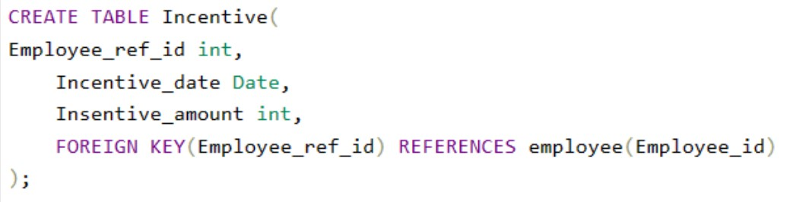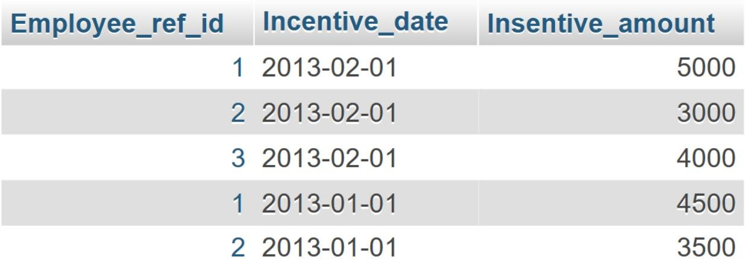

3. **Get First_Name from employee table using Tom name “Employee Name”.**





4. **Get FIRST_NAME, Joining Date, and Salary from employee table.**

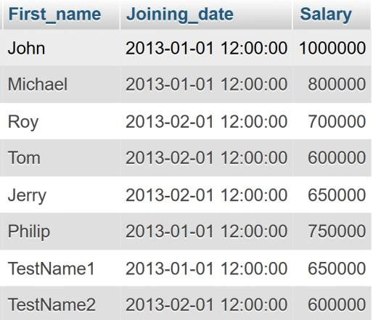

5. **Get all employee details from the employee table order by First_Name Ascending and Salary descending?**



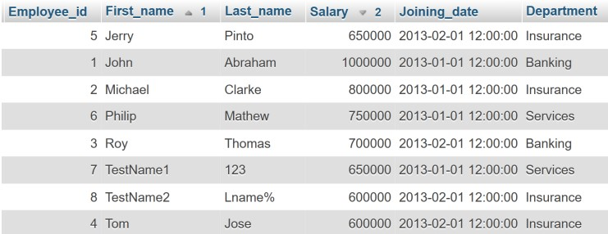

Decreasing:-

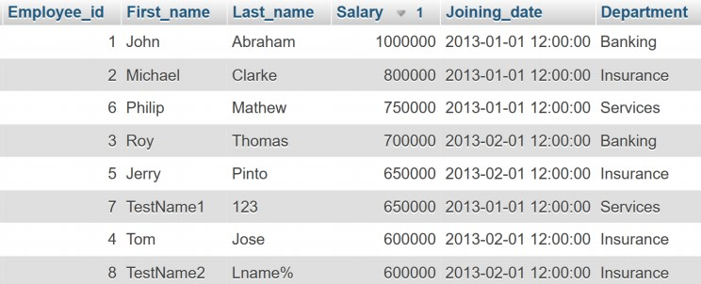

6. **Get employee details from employee table whose first name contains ‘J’.**

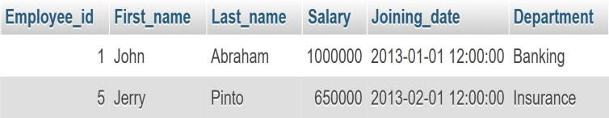

7. **Get department wise maximum salary from employee table order by salary ascending?**

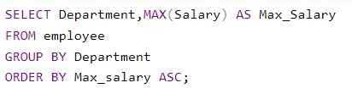

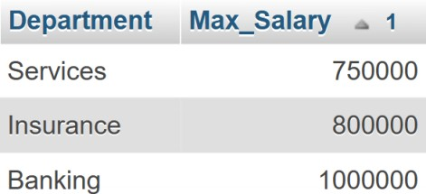

**8.Select first_name, incentive amount from employee and incentives table for those employees who have incentives and incentive**

**amount greater than 3000.** ➢ Solution:

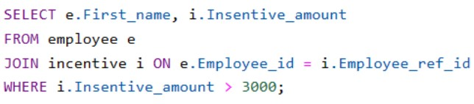

**9.Create After Insert trigger on Employee table which insert records in view table.**

* Creating View Table:

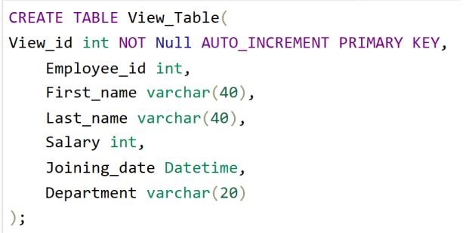

* Creating Trigger:

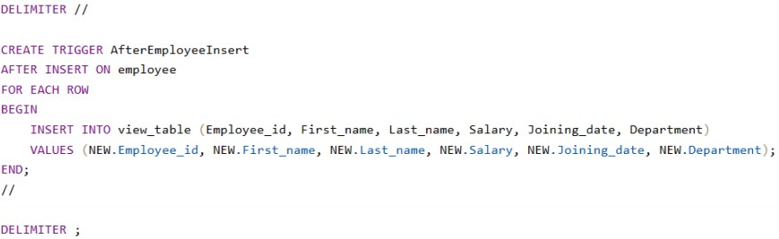

* Employee Table:

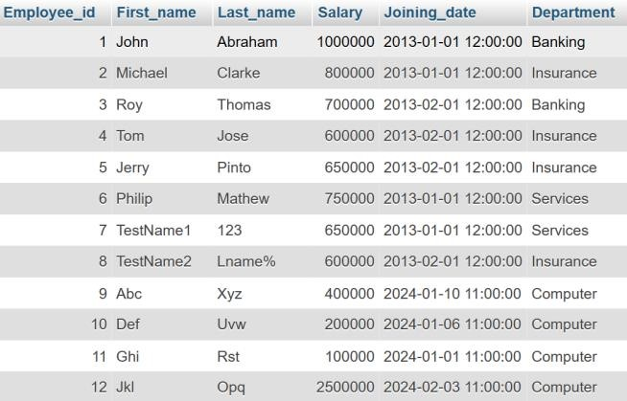

* View Table:



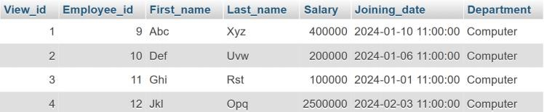

10.Create table given below: Salesperson and Customer.

➢

Solution:

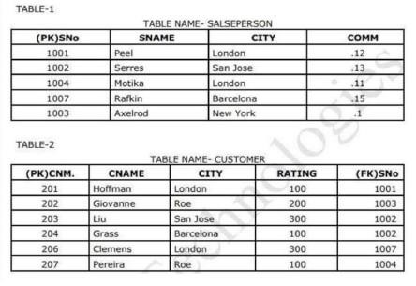

* Creating salesperson table:

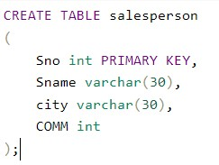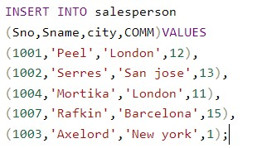

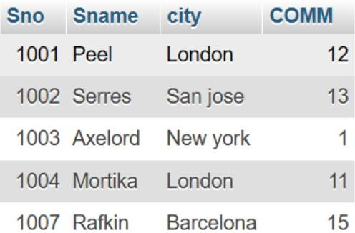

* Creating customer table:

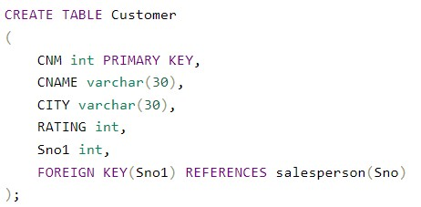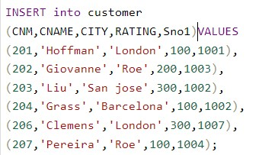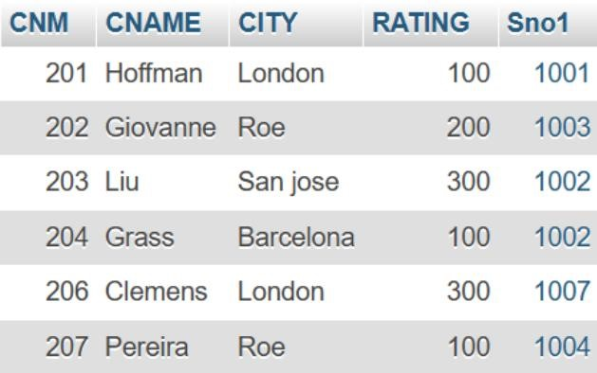

1. Retrieve the below data from above table
2. All orders for more than $1000.
3. Names and cities of all salespeople in London with commission above 0.12

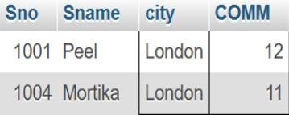

All salesperson either in barcelona or in London.

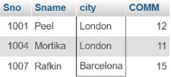

All salespeople with commission between 0.10 and 0.12. (Boundaryvaluesshould be excluded).

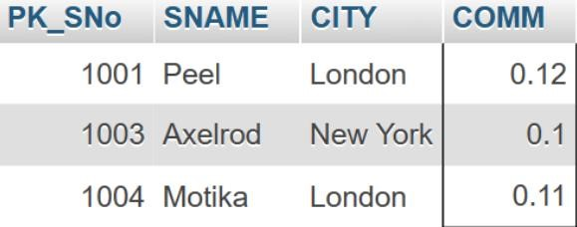

1. All customers excluding those with rating <=  
   100 unless they are located in Rome. ➢ Solution:

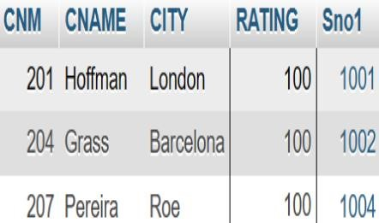

17.Write a SQL statement that displays all the information about all salespeople.

➢

Solution:

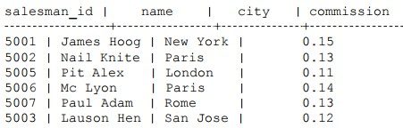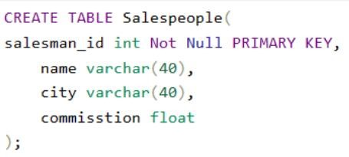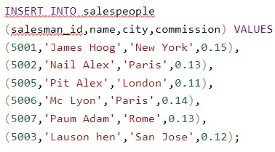

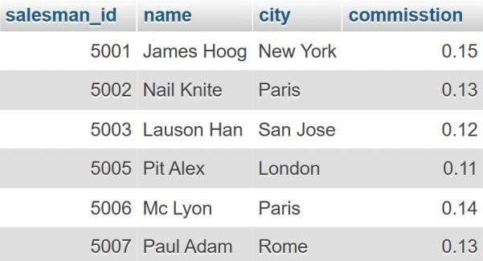

18.From the following table, write a SQL query to find orders that are delivered by salesperson with id.5001.Return ord_no, ord_name, purch_amt.

➢

Solution:

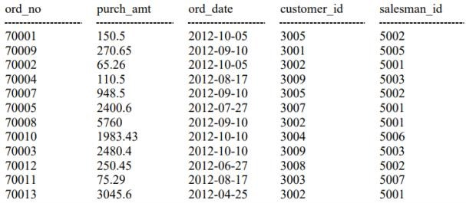

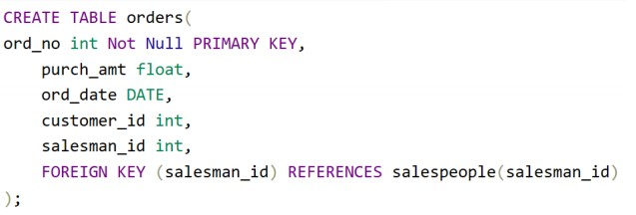

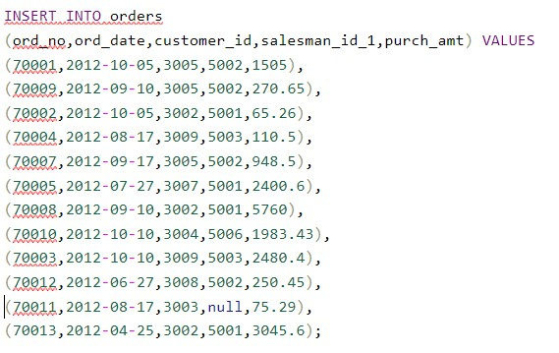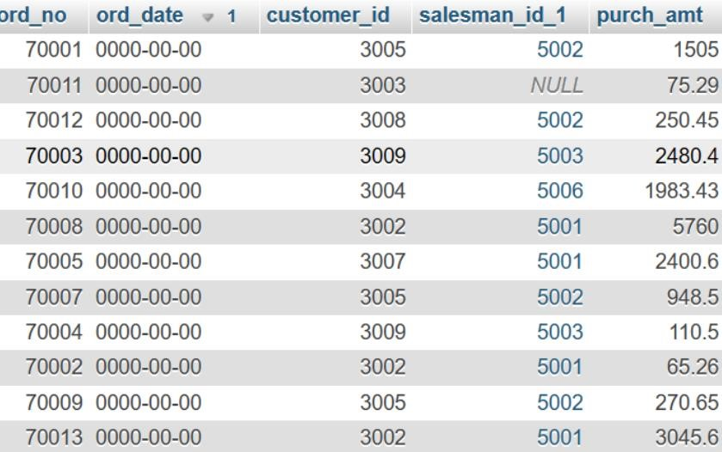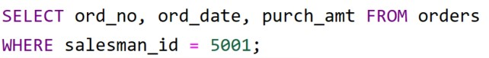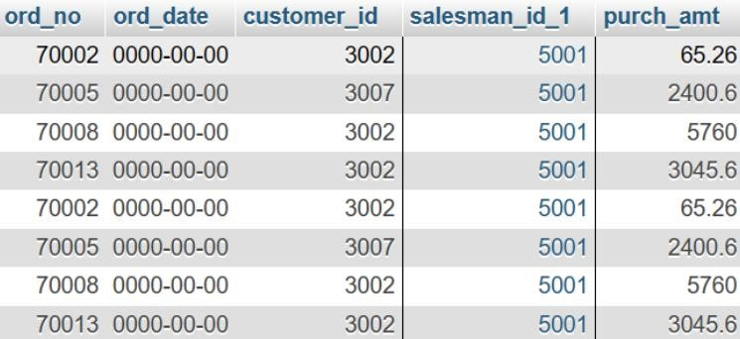

18.From the following table, write a SQL query to select a range of products whose price is in the range Rs.200 to Rs.600. Begin and end values are included. Return pro_id, pro_name, pro_price, and pro_com.

➢

Solution:

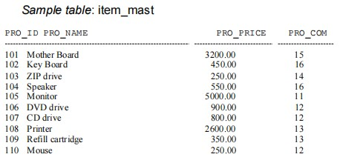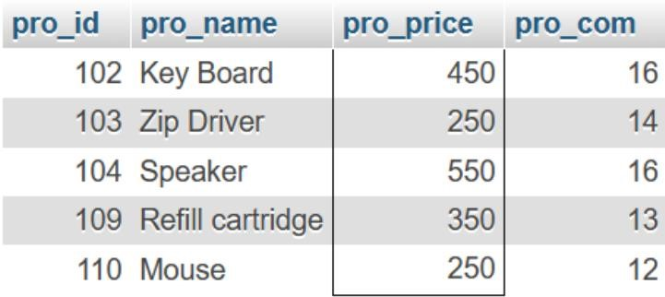

19.From the following table, write a SQL query to calculate the average price for a manufacturer code of 16. Return avg.

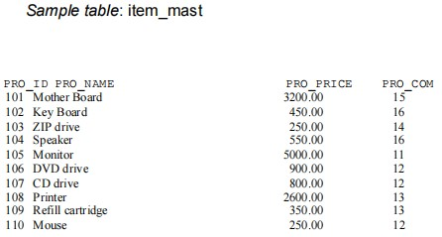

Solution:

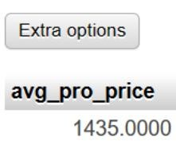

21.From the following table, write a SQL query to display the pro_name as 'Item Name' and pro_priceas 'Price in Rs.'

➢

Solution:

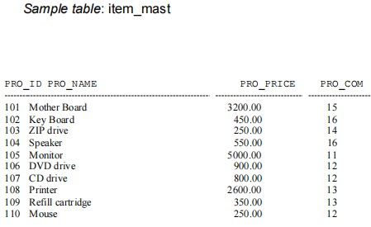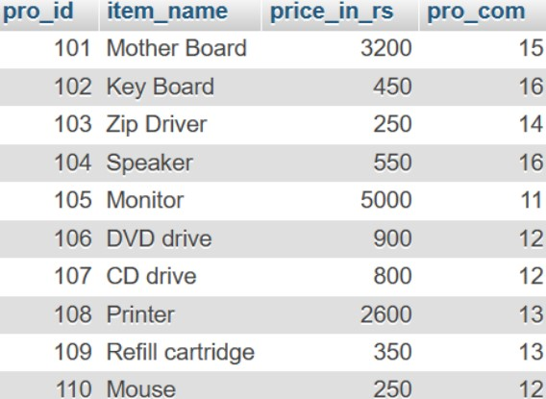

22.From the following table, write a SQL query to find the items whose prices are higher than or equal to $250. Order the result by product price in descending, then product name in ascending.

Return pro_name and pro_price.

➢

Solution:

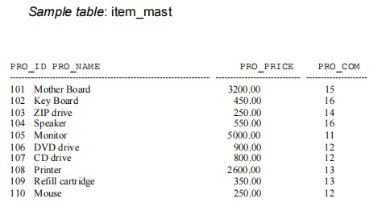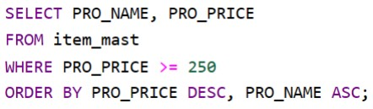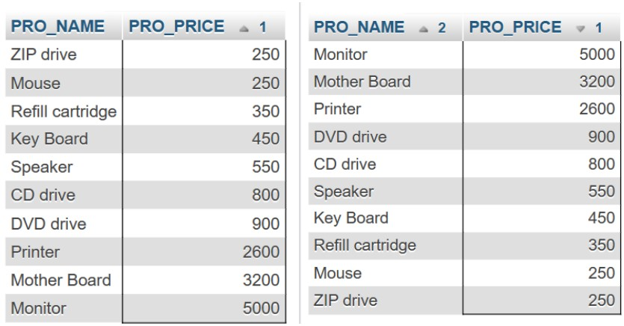

23.From the following table, write a SQL query to calculate average price of the items for each company. Return average price and company code.

➢

Solution:

